**Project Title:** APPLE STORE APPS DATA ANALYSIS USING SQL

**Description:** In this project I have analysed the Apple Store Apps Data using SQL to do Exploratory Data Analysis, Find the Insights and got the Final Recommendations to suggest the aspiring app developer Stakeholder to decide what type of App to build.

**Steps:**

1. Project Content: Downloaded the Apple store data from YouTube.

2. Connect to Dataset: Used SQLite online to Import the data.

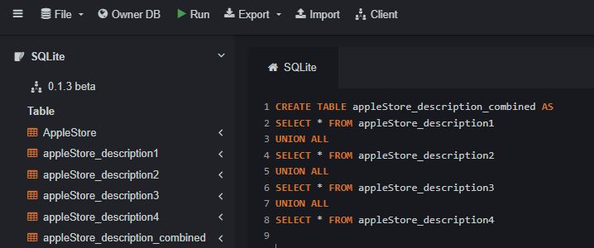

3. Identify the Stakeholders: Aspiring App Developer who needs data driven insights to decide what type of app to build.

- What app categories are most popular?

- What price should I set?

- How can I maximize user ratings?

4. Exploratory Data Analysis (EDA): EDA helps us to understand the characteristics of the data structure and often reveals issues in the dataset that need to be addressed before further analysis. The issues might include missing or inconsistent data and so identifying these issues early can save us a lot of time and effort in later stage of the analysis.

- Check the number of unique apps in both tables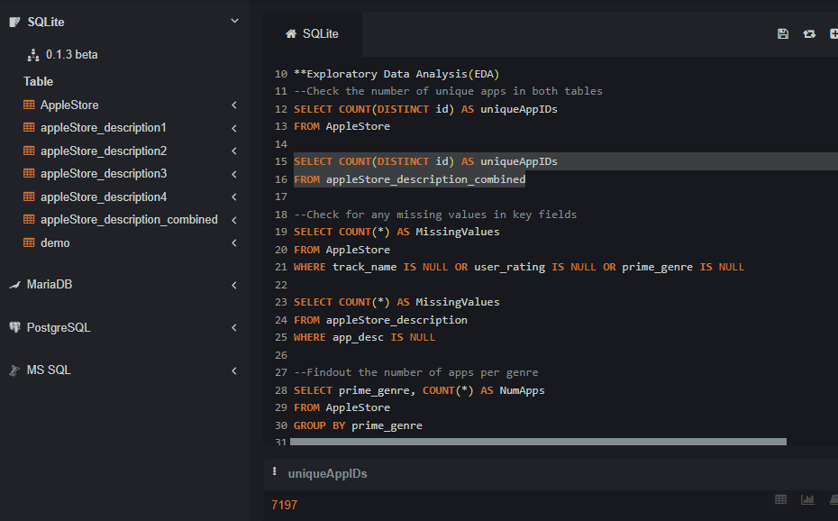

- Check for any missing values in key fields

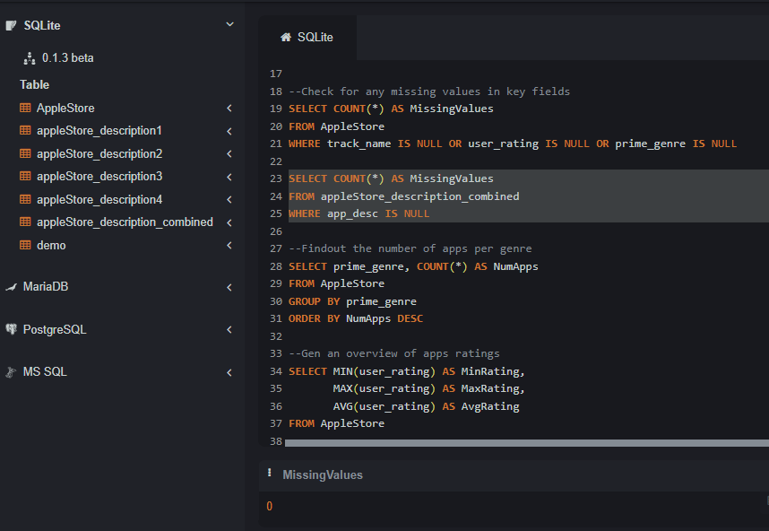

- Find out the number of apps per genre

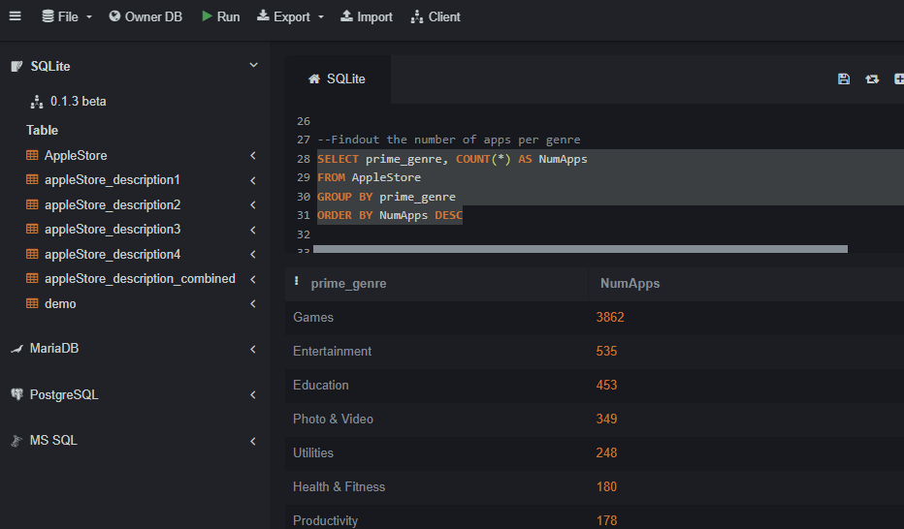

- Get an overview of apps ratings

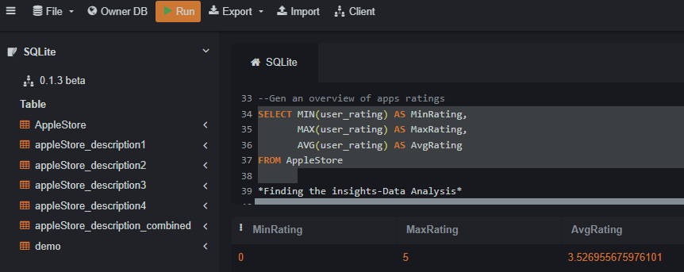

5. Finding the Insights-Data Analysis:

- To Check if paid apps have higher rating than free apps

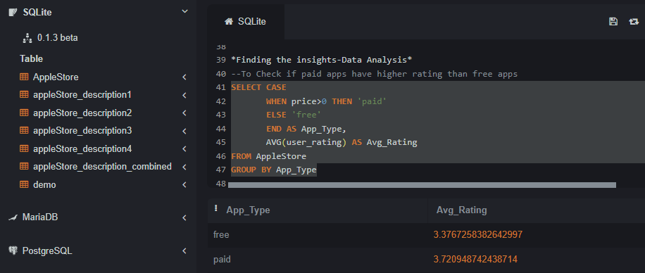

- To Check if apps with more supporting languages have higher rating

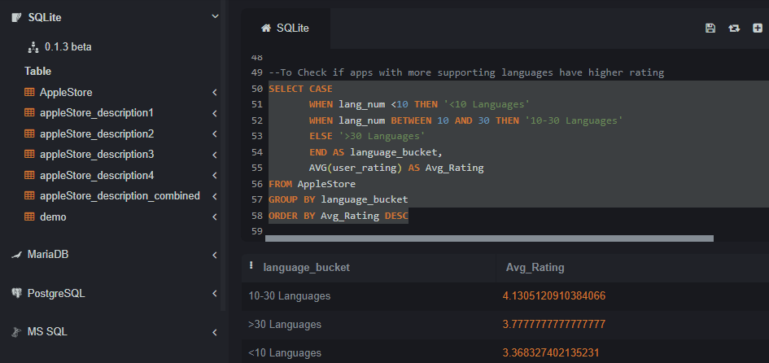

- Check genres with low ratings

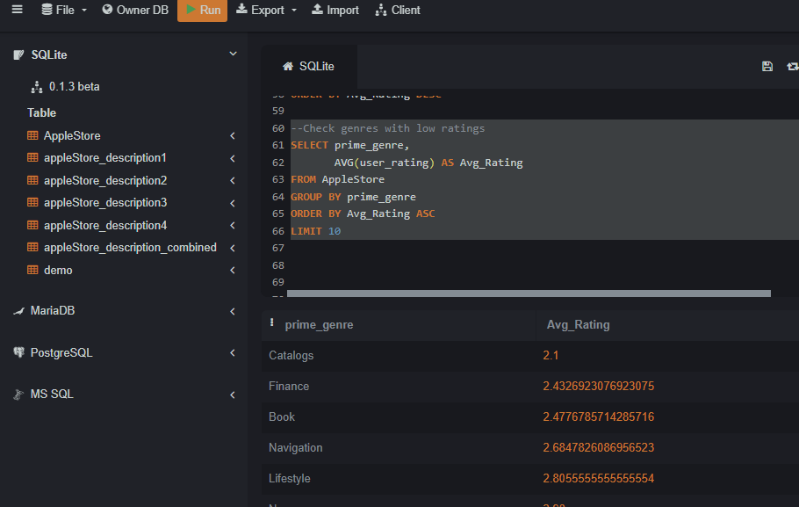

- Check if there is correlation between the length of the app description and the user rating

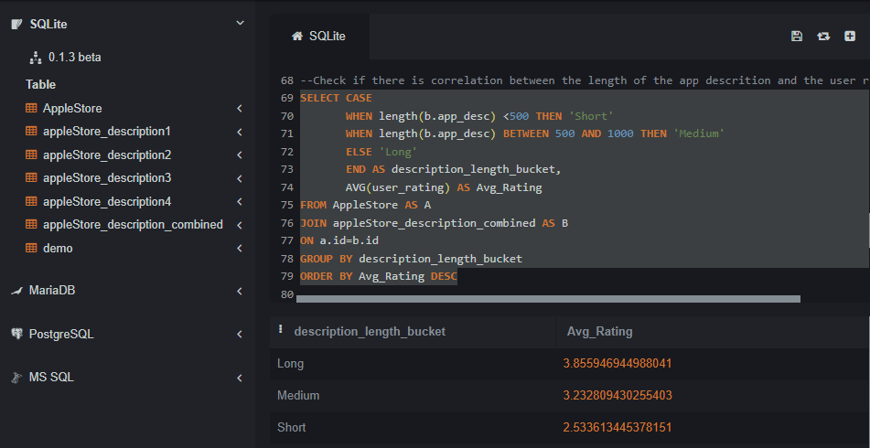

- Top Rated Apps for each genre

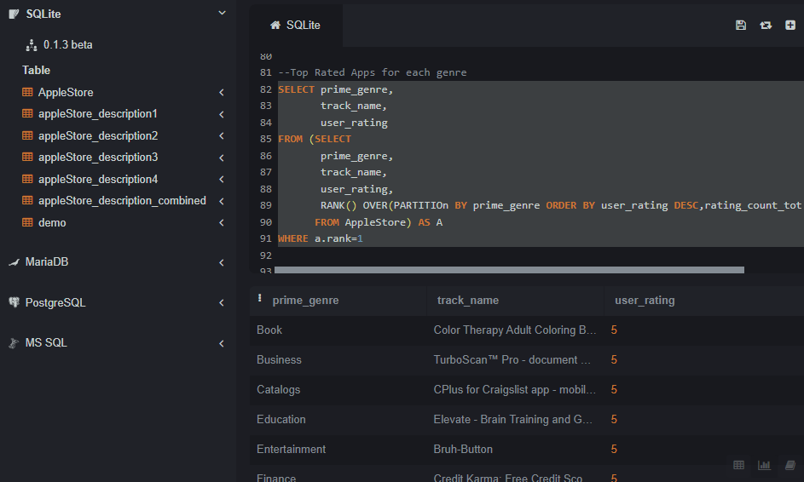

6. Final Recommendations:

* Paid Apps have better ratings.
* Apps supporting between 10-30 languages have better ratings.
* Finance and book apps have low ratings.
* Apps with longer description have better ratings.
* A new app should aim for an average rating of 3.5
* Games and Entertaining category have high competition.